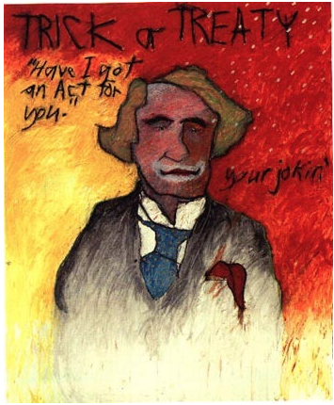  Gerald McMaster, Trick or Treaty, 1990  Retrieved from https://terresauvage.tumblr.com/post/107841356753/gerald-mcmaster-trick-or-treaty-1990-what-i | “What I did here was inspired by a poster of Jack Nicholson as the Joker, so it became very Hallowe'enish – with the colours, ‘trick or treat.’ I felt that 'TRICK OR TREAT’ was actually the same word, or had the same implications. Whether they signed it or not – and a lot of Indians never did sign a treaty – it meant the same thing. There was never any advantage at all to Native peoples. It was all to their disadvantage. 'You’re damned if you do and damned if you don’t.’ I think that there were no treats at all! So I saw it as a cruel joke.”  Gerald McMaster
Considering your responses to the Indian Act Survey and what you have learned through the podcast, readings, course materials and your own research, respond to the following question:
- What do you feel the Indian Act, in its current state, reflects about the relationship between First Nations and Canadian Society?
  - In your response, consider the Indian Act with respect to opportunities for First Nations self-government.
  - Use information from the course, podcast, Indian Act timeline, and your own research to provide support for your opinion and ideas.
Represent your understanding in both of the following two components:
- An original artistic piece created by you
  - This could be:
    - an original image, collage, painting you create,
    - a recording of an original song
    - a poem
    - an advertisement or poster educating Canadians about the Indian Act
  - Ensure that you include a short paragraph explaining the meaning of your artistic piece
- A 2 - 3 page, double spaced essay responding to the assignment question:
  - "What do you feel the Indian Act, in its current state, reflects about the relationship between First Nations and Canadian Society?"
  - Ensure that you support your thesis with evidence, and that you explain how the evidence and examples you provide support your thesis.
  - Ensure that you cite your sources in APA format.
  - Use the student tools section of the course to support your writing format and reference citations.

